On the Shape of the Universe

Author names and affiliations
John A. Hobson^{1*}

Quote
“Nature is an infinite sphere of which the centre is everywhere and the circumference nowhere.” Blaise Pascal, Pensées (1670)

Abstract

ABSTRACT
It is proposed that the observable universe, also the entire universe, is a 3-sphere, the 3D surface or boundary of a 4-dimensional ball with the dimensions of spacetime and with a radius expanding at the speed of light. Such a universe would be three dimensional, homogenous, finite, yet unbounded. Although finite in size, there is no limit to the distance that can in principle be observed. The apparent distance to the big bang, for any observer is infinite. Light in this proposed universe follows paths described by an equiangular spiral. The proposed universe has a current Hubble constant calculated to be 71.7 km/s/megaparsec in good agreement with the currently accepted value. The constant is predicted to be decreasing with time and to have been infinitely large at the moment of the big bang. Every object in the proposed universe is by definition moving with spacetime at the speed of light which fits very well with the special theory of relativity. The model can be used to predict how the observed number of galaxies varies with redshift and agrees well with recently published data. The proposed model predicts that the universe has a characteristic mass, calculated to be 8.9 x 10⁵² kg, a density of 1.5 x 10⁻²⁷ kg/m³. This mass must increase as the universe expands. The current value of the vacuum energy is calculated to be 5.1 x 10⁻²⁸ kg/m3. The current density of the universe in this model is calculated to be approximately one quarter of the critical density. This value must decrease as the universe expands. The model also leads to a possible explanation for inflation based on simple geometry. Finally, at low redshift values the proposed model produces a relationship between distance and red shift almost indistinguishable from that produced by Λ-CDM models. Data such as that obtained by Saul Perlmutter, which when fitted to a Λ-CDM model indicates the expansion of the universe is accelerating, could equally as well support the proposed model with its constant rate of expansion.

Keywords
Subject Keywords: Shape of the Universe _ Hubble constant _ Special relativity _ Distribution of galaxies _ Mass of the Universe _ Vacuum energy

- Introduction
This paper presents a model of the universe which, despite its extreme simplicity, contains significant explanatory value, providing values for the Hubble constant, the mass of the universe and the size of the vacuum energy, which agree well with values estimated by other methods. The model universe is finite yet unbounded. It is isotropic and despite being finite in size it places no limit in principle on the maximum distance of observation as measured in the present universe. It provides an explanation for how the observed density of galaxies varies with redshift which agrees well with recent data and even provides an explanation for inflation based on simple geometry. It deserves consideration.

- The Model
If we take the big bang as a starting condition, then our universe is expanding from a point. The simplest model for this would be an expanding 3-dimensional ball. Now it is extremely unlikely our universe can simply be an expanding 3-dimensional ball. A simple expanding 3-dimensional ball would not be homogenous. It would contain a centre, the point of the big bang, and an edge. In any case we know that our universe contains at least four dimensions, three of space and one of time. So the next simplest model for the universe is an expanding 4-dimensional ball. This is the model that this paper explores. It seems to hold significant explanatory value.

- Homogeneity
If we inhabit an expanding 4-dimensional ball, we have the same problem as for a 3-dimensional expanding ball, it would not be homogenous, containing both a centre and a boundary. However, a 4-dimensional ball has a particularly interesting property. A 4-dimensional ball has a 3-dimensional surface known as the 3-sphere or glome. It is proposed that our universe is this 3-sphere. This surface is a totally homogenous, finite yet unbounded, three dimensional space. A 3-sphere appears to describe our observable universe very well. This is closely analogous to the case of a 2-sphere such as the Earth. In this case the surface is two dimensional, providing the fine scale topography is ignored. The surface of the earth is unbounded, there is no edge, and every point is equidistant from the centre, which does not exist on the surface. However, though the surface of the Earth is a curved two dimensional surface, the curvature could not exist if it were not for the presence of a third dimension. Similarly, our 3D surface, the 3-sphere, could not exist without the presence of a 4th dimension.

The three dimensional surface of a four dimensional ball may be difficult to envisage but it has an extremely simple formula

x² +y² +z² +t² =r² (1)

For our purposes this can be rewritten.

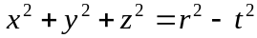 (2)

Where r is the radius of the 3-sphere, also equal to the radius of the 4-dimensional ball. Equation (2) is not however dimensionally consistent, it is not possible to add length to time. This can be rectified by multiplying time by a constant with the dimensions of speed, with the obvious candidate for such a constant being the speed of light c. This is standard practice in the field of relativity. This leads to the following formula.

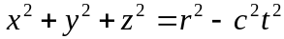 (3)

Equation (3) can be rewritten as shown in equation (4), where r is replaced by ct₀.

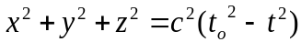 (4)

t_{o} can be considered to be the age of the universe and t varies from –t_{o} to +t_{o}. As the universe ages, t_{o} increases so the universe expands. This model describes a universe with a radius increasing at the speed of light. Although this formula is in four dimensions, it describes a 3-sphere, which is a three dimensional object.

This model predicts that the radius of the universe is expanding at the speed of light. If the universe is 14 billion years old [1], as currently estimated, it will have a radius of 14 billion light years. However the furthest observed objects in the universe have been estimated to be around 46 billion light years away [2] and this might increase as imaging technology improves. We can see such objects because when their light was emitted they were much closer to us. At first sight, this does not appear to support the proposed model if the universe has a radius of only 14 billion light years. However we ‘see’ through the 3-sphere. All of our observations are on (or in) the 3-sphere. If the 3-sphere has a radius of 14 billion light years, it will be associated with a length or ‘circumference’ of π.d, or around 88 billion light years. This provides ample space for observed distances.

A more detailed consideration of the proposed model presented in Section 6 suggests that there is in fact no limit to observable distances in units appropriate to the current universe though 88 billion ly is a very significant distance.

- The Hubble Constant and Inflation

This proposed model can be used to calculate the Hubble constant. Although distances in the 3-sphere can be much greater than its radius they will still have the property that a doubling of the radius will lead to a doubling of the distance between two points on the surface. The best estimate for the age of the universe is 13.8 billion years. The proposed model therefore predicts a radius for the universe of 13.8 billion ly. All points separated by this distance, whether from the centre to the surface of the 4-dimensional ball or two points within its surface, the 3-sphere, will be moving apart at the speed of light. So if two points 13.8 billion light years apart are separating at the speed of light this is equal to an expansion of 71.7 km s⁻¹ megaparsec⁻¹. The Hubble ‘constant’ has been estimated at 73.8 ± 2.4 km s⁻¹ megaparsec⁻¹ [3]. The proposed model predicts the current value of the Hubble constant rather well.

The Hubble ‘constant’ predicts a relative rate of expansion. If however it is the absolute rate of expansion that is constant, as in the proposed model, then the Hubble ‘constant’ is actually a variable and must be decreasing with time. Conversely, a constant absolute expansion rate as this model predicts, leads to a prediction that the relative expansion rate, the Hubble ‘constant’, gets larger as the universe gets younger and smaller and is in fact infinitely large at the moment of the big bang. An infinitely large Hubble constant at the moment of the big bang superficially seems consistent with the general concept of inflation [4]. However, in detail, on its own, it is not sufficient to explain inflation. See section 6 however for one way the proposed model accounts for inflation.

- Special relativity

An interesting way of viewing special relativity is to consider that all objects, or points, in the universe are travelling through spacetime at exactly the speed of light [5]. The speed of light through space being 300,000 km/s and through time it is one second per second. This leads to Einstein’s famous equation E = m_{o}c². (In classical mechanics the kinetic energy would be 0.5 m_{o}c² but a consideration of both energy and momentum for motion in spacetime, leads to Einstein’s equation). So all objects at rest in space are travelling through time at 1 second per second. As an object acquires velocity in space, the limiting speed of light requires that it slows down in time leading to the almost equally famous equation for time dilation and from which the rest of special relativity can then be derived. But why is every object in the universe travelling through spacetime at the speed of light? Well this is exactly what is predicted by the proposed model. Every point in the 3-sphere is exactly a distance r, approximately 14 billion ly, from the centre of the 3-sphere. And since in the proposed model the radius of the 3-sphere is expanding at the speed of light, then it follows that every point on (or in) the 3D surface is moving through, or with, spacetime at the speed of light. It is not suggested this leads automatically to the special theory of relativity but it is at least highly compatible with the special theory of relativity.
- The mechanics of the model.

Before considering the mechanics of the proposed model in detail it is worth considering a possible paradox. When an observer looks out into the universe, at a constant solid angle, his field of view will increase the further he looks. In fact its area will increase as the distance squared. But if the observer looks far enough into an expanding universe, he might be expected to observe the big bang, a single point. Clearly this requires some explanation. A simplistic consideration of the proposed model points to a resolution of this paradox. Consider a 2-sphere such as the earth. If an observer, placed at the south pole for convenience, looks along two lines of longitude (geodesics in this system) the distance between these lines will at first increase in proportion to the distance viewed, but the rate of increase of this separation will reduce until it reaches zero at the equator after which the separation will reduce back down to zero at the north pole.

In an analogous way, the same should hold for a 3-sphere where area of view replaces distance of separation. If this is correct then for any observer in the universe, all observed rays of light will have emanated from a single point at his own unique antipodal point, a distance of 44 billion ly away. On a first consideration it might seem likely that this antipodean point is in fact the origin of the big bang. However, a more detailed consideration of the model predicts that this is not the case, in a rather surprising way.

This detailed consideration is made with reference to Figure 1, a cross section of the expanding universe at 14 time steps of 1 billion years. An observer is placed at the point B. The path of an incoming light ray can be traced (in reverse) by considering it to first travel in the current universe and then move radially as the universe contracts. This is shown for three time steps by the cyan path. It is possible to continue this process for the full 13 time steps, but it becomes apparent that as the origin approaches, something odd happens and the curve becomes somewhat pathological. In particular the path of the curve becomes very dependent on the time step chosen. Fortunately there is a formula that can be used to produce the path of the light ray. The identity of this formula can be understood as follows. The light ray is always moving tangentially through the surface of the universe at the speed of light and radially towards the centre, also at the speed of light. Nb, the light ray is always moving in the 3D surface of the universe as it contracts – it never needs to travel in four dimensions. The light ray is therefore at all times making an angle with the surface of its present universe, of 45 degrees. The curve of the light path is an equiangular spiral, of nautilus shell, Fibonacci series and golden ratio fame. This has the following formula, in polar co-ordinates.

r = a exp(ϴ cot b) (5)

b is 45 degrees so cot b is 1. In order to produce a universe with a radius of 14 billion ly, the constant a is equal to 14/4.81 billion ly. The resulting light path is shown by the upper red curve. If the observer looks in the opposite direction the incoming ray of light will take the lower red curve. Now take a light ray arriving at B from the universe 7 billion years ago, from either of points 7 or 7’. In the 7 billion years it takes for the light to travel from 7 to B, point 7 will have expanded with the universe to point R1. The observer B is unaware of exactly how the light ray is bending and will see point 7 as if it were at R1 in the present universe. And since in this time the universe has doubled in size the cosmological redshift is 1. Similarly 12 billion years ago, when the universe was 2 billion years old, the universe will have expanded 7-fold, to give a red shift of 6, as shown and from 13 billion years ago the expansion wil be by a factor of 14 to give a redshift of 13.

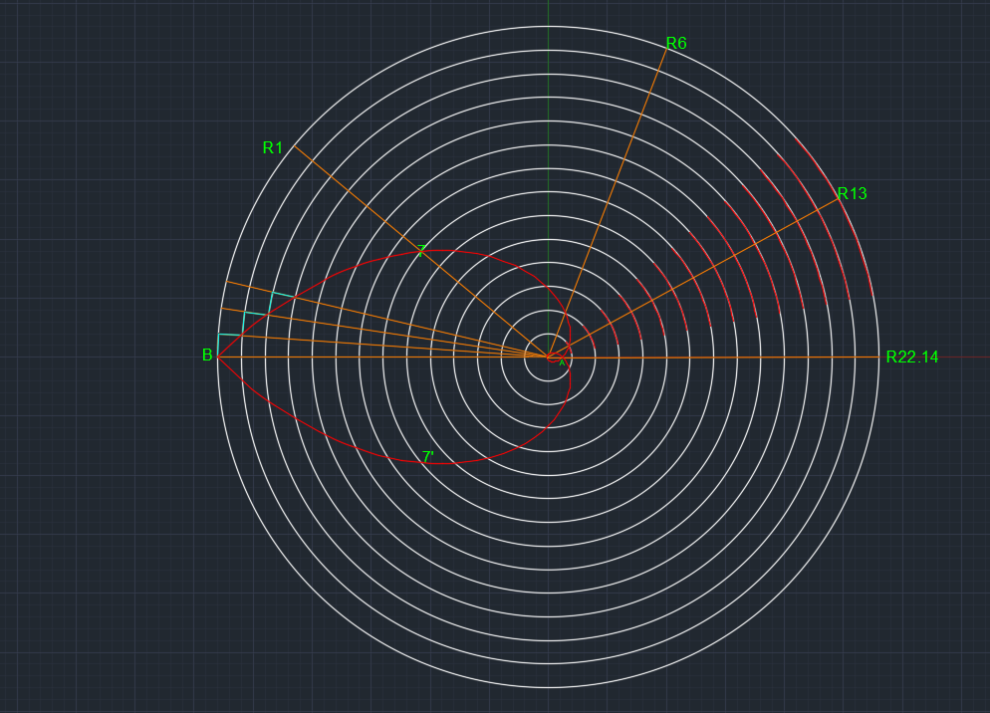
Figure 1. A cross section through the proposed universe, as it expands during 14 equal timesteps each of 1 billion years since the big bang. The numbers around the circumference show red shifts. The red curves are the paths of light in this expanding universe following an equiangular spiral. Nb this curve never reaches the origin, the point of the big bang.

The case marked R22.14 is particularly interesting. This point is at an apparent distance of 44 billion years from the observer B, making an angle of pi radians around the current universe. At this point both light rays meet, at B’s antipodean point, as predicted by the simpler consideration, presented above, but this point is not in fact the centre of the universe. The observer is in fact seeing a point when the universe was 0.6 billion years old with a red shift of 22.14. By looking in both available directions up to a redshift of 22.14, the observer has for the first time seen the entire universe older than that appropriate to the redshift, in this case 0.6 billion years. But there is nothing in principle to prevent him from looking further. How can this be? When he looks further the points he sees start to overlap. As he looks further he sees an increasing number of points twice. Some points he sees looking in one direction are the same as those he has already seen looking in the other direction, but at a different age. By the time he has looked 88 billion ly into the universe, an angle of 2 pi, if that were not made impossible due to lack of transparency, he will see his own position, as it was at an age of just 26 million years and a red shift of 535 and he will have seen the entire universe older than that, twice. Note that the equiangular spiral never actually reaches the origin. It just continues to get ever closer. This means an observer can in priciple continue to look deeper into the universe, but he will never see the instant of the big bang. That point is infinitely far away as far as distance in the current universe is measured. Table 1 sumarizes these points.

Age observed,  billion years | Angle made, radians | Apparent distance, billions ly | redshift | comments
7 | 0.7 | 9.8 | 1
2 | 1.9 | 26.6 | 6
1 | 2.6 | 36.4 | 13
0.6 | pi | 44 | 22.1 | First convergence point
0.026 | 2 pi | 88 | 535 | Second convergence point, ‘self’ image.
0 | ∞ | ∞ | ∞ | The big bang

Table 1. A selection of significant parameters in the proposed universe.

Figure 1 is 2-dimensional. The observer B exists in only 1 dimension and can only look in 2 directions. But Figure 1 can be taken to be a cross section of a 3-dimensional expanding ball, in which case an observer B exists in a 2 dimensional space, much like the surface of the earth. He can look in any direction around a circle and all observations at 44 billion light years will come from his antipodean point. And Figure 1 can be considered to be a cross section of a 4 dimensional expanding ball. In this case observer B exists in a 3 dimensional space, the 3-sphere. He can look in any direction around a sphere but again, all observations made from 44 billion years ago, come from his antipodean point, with a redshift of 22.1.

Figure 1 can be used to estimate how a volume element changes as an observer looks increasingly deeply into the universe. This in turn can then be used to make a prediction about how the number of galaxies will increase on observing deeper into the universe.

Let the observer, B, be looking at a galaxy with redshift 1, point R1. He will in fact be seeing photons coming from point 7, from the universe as it was 7 billion years ago, when it was 50% of its current size. The apparent distance to R1 is 9.8 billion ly.

If the observer, B, looks in the opposite direction he will see a different trajectory, the lower red curve. The arc length from point 7 to the corresponding point on the lower curve, is the distance apart of the two points observed in the 7 billion year old universe. The arc length from B to R1 is 50% of this distance when projected onto the current universe. The ratio of arclengths B-R1 to B-R22.14 is the linear fraction of the universe observable out to redshift 1. For the 1-dimendional surface of a 1-sphere (a circle) it is 0.22. The observable volume fraction out to a redshift of 1 for the 3-sphere is this value cubed, 0.01.

Table 2 shows the results of this calculation using the proposed model for the full lifetime of the universe. If the universe has contained a constant number of galaxies, distributed evenly, over its whole life, then the differential volume elements in the table should be proportional to the increase in galaxies observed on moving to increasing redshift. Figure 2, from Conselice et al [6] shows an estimate for how the number of galaxies in the universe varies with redshift. The proposed model makes no estimate of the number of galaxies in the universe so it is reasonable to normalize the volume elements in Table 2 to allow them to fit onto Figure 2. This is done in the final column where the value has been set to 0,08 at a redshift of 1. These normalized volume elements are then plotted onto Figure 2 using the values of the redshift contained in column 3. Of course the number of galaxies in the evolving universe has not been constant. In particular, below a certain age, above a certain redshift, there will be no galaxies at all. Above a certain redshift the number of galaxies in view must fall below the predicted curve. In the nearby universe local fluctuations in density are more likely to lead to deviations from the proposed curve. More especially, the Milky Way belongs to a local cluster of galaxies, which cluster belongs to a supercluster, once thought to be the great attractor but more lately thought to be the even larger Shapely supercluster. Certainly up to around 1 billion ly away, a redshift of 0.08 in the proposed model, the number of galaxies is certain to exceed the proposed curve. At greater distances still it is quite likely we will have a local void where the density of galaxies will be below the predicted curve. Above a certain redshift, local deviations in density should balance out and the number of galaxies in view should follow the curve until the number starts to decrease as the very early universe is approached. It is suggested that the distribution of galaxies in Figure 2 does follow the proposed curve, with an excess in the nearby universe followed by a deficit with possibly the beginning of a second deficit at the highest redshifts shown.

age of universe | associated angle |  | Redshift | linear fraction observed |  | volume fraction observed (vfo) |  | delta vfo | normalised delta vfo
14 | 0 |  | 0.0 | 0.00 |  | 0.00 |  | 0.000 | 0.000
13 | 0.07 |  | 0.1 | 0.02 |  | 0.00 |  | 0.000 | 0.000
12 | 0.15 |  | 0.2 | 0.05 |  | 0.00 |  | 0.000 | 0.001
11 | 0.24 |  | 0.3 | 0.08 |  | 0.00 |  | 0.000 | 0.004
10 | 0.33 |  | 0.4 | 0.11 |  | 0.00 |  | 0.001 | 0.010
9 | 0.44 |  | 0.6 | 0.14 |  | 0.00 |  | 0.002 | 0.022
8 | 0.55 |  | 0.8 | 0.18 |  | 0.01 |  | 0.003 | 0.043
7 | 0.69 |  | 1.0 | 0.22 |  | 0.01 |  | 0.005 | 0.080
6 | 0.84 |  | 1.3 | 0.27 |  | 0.02 |  | 0.009 | 0.145
5 | 1.02 |  | 1.8 | 0.33 |  | 0.04 |  | 0.016 | 0.259
4 | 1.25 |  | 2.5 | 0.40 |  | 0.06 |  | 0.028 | 0.468
3 | 1.53 |  | 3.7 | 0.49 |  | 0.12 |  | 0.054 | 0.884
2 | 1.94 |  | 6.0 | 0.62 |  | 0.24 |  | 0.120 | 1.842
1 | 2.63 |  | 13.0 | 0.84 |  | 0.59 |  | 0.355 | 4.961
0.6 | 3.14 |  | 22.1 | 1 |  | 1 |  | 0.41 | 6.46

Table 2. This shows the angle of view associated with observations to different ages in the universe, and the associated redshift. The angle of view divided by pi, column 4, is the linear fraction of the universe that is observable. This value cubed is the volume fraction that is observable, column 5. The delta values are the volume fraction of the universe that is observable in observations between the redshift values. If the universe were to contain a constant number of galaxies, evenly distributed then these values will be proportional to the number of galaxies observed on moving between these redshift values. Since this model makes no prediction about the number of galaxies in the universe the values have been normalized to 0.08 at a redshift of 1 for comparison with data presented by Conselice et al.

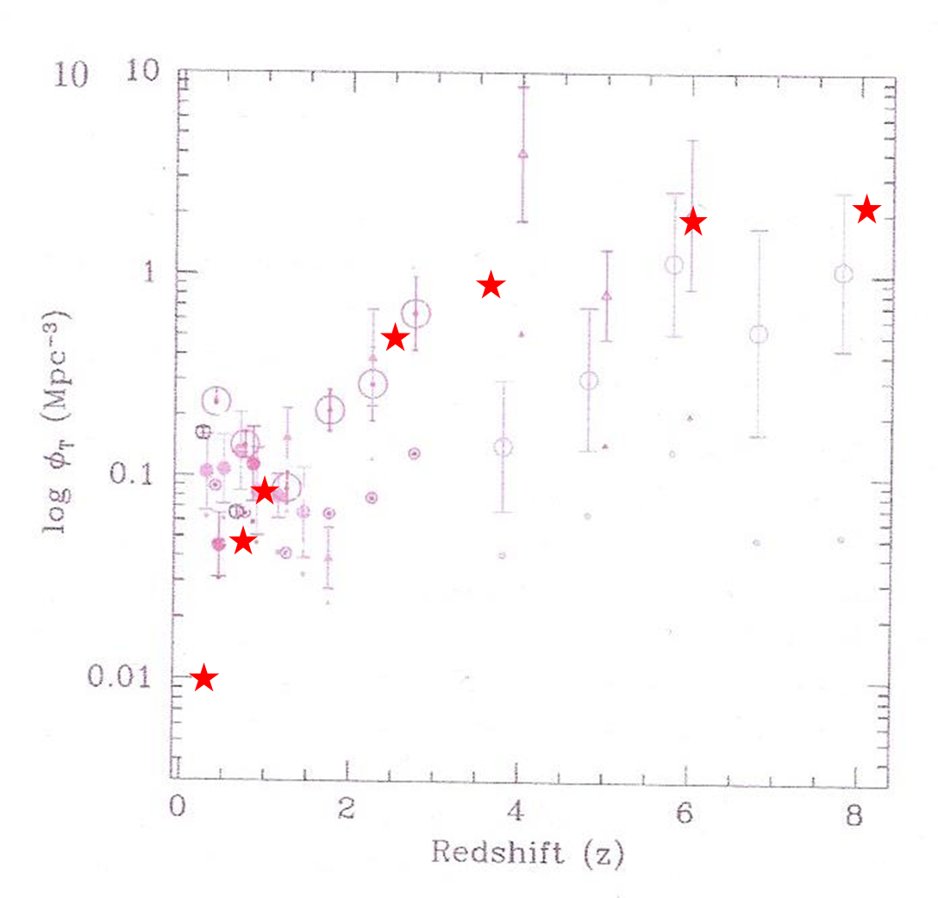

Figure 2. Data on the density of galaxies vs redshift taken from Conselice et al [6]. "© AAS. Reproduced with permission". The red stars show the percentage of the universe predicted by the proposed model to be in view at various redshifts, determined by the proposed model, normalized to 0.08 at a redshift of 1. The curve defined by the red stars will follow the density of galaxies if the number of galaxies has been fixed over time and they are evenly distributed. In the nearby universe, the local supercluster of galaxies means that the number observed will exceed that predicted by this curve. In the very young universe there will be less galaxies than at present and so the number observed will fall below the curve.

There is a sense in which the proposed model could account for inflation. Every time a photon makes a circuit of the proposed universe, its projected path onto the current universe is 88 billion ly. But each circuit leads to an increase in the radius of the universe by a factor of 535 or 10^{2.73}. From the Planck length to the current universe, a factor of 10⁶¹, a photon will have made around 22 circuits of the universe. During the first circuit, any structure in the universe will apparently be magnified by a factor of around 10⁶⁰. If it were possible to observe a photon at this time, its apparent velocity would have been around 10⁶⁰ times the speed of light. In fact there was probably no structure in such an early universe. After such a photon has made around 10 circuits, the universe will be atom sized and quantum fluctuations will probably have appeared. The apparent size of these fluctuations will have been magnified by approximately 10³⁶ times as seen from the current universe. A photon from this moment, if visible now, would appear to have been travelling at around 10³⁶ times the speed of light. This could easily be interpreted as inflation. In this model of the expanding universe, inflation is only a virtual phenomenon, as early structure is projected onto the current universe. At no time has the universe ever been expanding faster than the speed of light. In the proposed model, inflation never in fact ends, it just gradually unwinds, and so cannot be used to imply the existence of a multiverse.

- Testing the model

There are a number of tests and predictions which could support the proposed model. Four have already been mentioned and so will be listed very briefly.

- The model makes no prediction about how far it is possible to look into the universe but a distance of 44 billion ly, with a redshift of 22.1 is a special case. All light with this redshift comes from a single point, the observer’s antipodean point at an age of 0.6 billion years. It is necessary to observe up to this redshift before the entire universe becomes observable. But an observer can still look further, to greater redshifts, and continue to see an ever younger universe. As telescopes improve in the future, it may be possible to see this far at a redshift of 22.1.
- The model predicts a Hubble constant of 71.7 km/s/megaparsec which is in very good agreement with the accepted value of 73.88 ± 2.4km/s/megaparsec.
- The model predicts that every object or point in our universe is moving at the speed of light which fits very nicely with the special theory of relativity.
- The variation in the number of galaxies observed with increasing redshift, as predicted from the proposed model, agrees well with values published by Conselice et al [6], particularly as the density of galaxies in the very nearby universe is certain to be greater than average, while it is likely to be less than average in the slightly less nearby universe and also the very young universe.
- The total mass of the universe.
Perhaps rather surprisingly, the total mass of the universe is predicted by the proposed model in a very simple way. Conselice et al [6] estimates the number of galaxies in the observable universe at 2 x 10¹². The mass range of galaxies is enormous, ranging from 10⁶ solar masses to 10¹² solar masses. Most of the mass is contained in the larger galaxies though there are far fewer of them. A mean mass of 10¹⁰ solar masses can be used to produce an estimate of the total mass as follows

Number of galaxies - 2 x 10¹²

Mean mass of galaxies - 10¹⁰ solar masses

Solar mass - 2 x 10³⁰ kg

The product of these numbers, 4 x 10⁵² kg, is a reasonable estimate for the mass of the observable universe by a ‘conventional’ approach.

The estimate from the proposed model comes about as follows. Any photon travelling in the 3-sphere is effectively orbiting the centre of the 3-sphere. It could therefore be understood that the speed of light is the escape velocity for this universe. Since the current radius of the 3-sphere is 14 billion ly, if the standard formula for the calculation of escape velocity still holds in this case, then the total mass of the universe results, as follows.

Formula for escape velocity.

Ev = (2 G M/r)^{0.5} (7)

Ev, escape velocity, C, 3 x 10⁸ m/s
G, gravitational constant, 6.67 x 10⁻¹¹

M, mass, unknown

r, radius, 14 billion ly

Equation (7) can be rearranged to give Equation (8).

M = Ev² r/2 G (8)

The resulting value for M is 8.9 x 10⁵² kg. This is an extremely respectable estimate for the mass of the universe. This calculation is identical to that which results from considering the 3-sphere to be a black hole.

- The vacuum energy

Perhaps even more surprisingly, the proposed model makes an extremely simple estimate of the vacuum energy. The value for the vacuum energy, closely related to the cosmological constant, is probably one of the more uncertain parameters in the field of cosmology (it is even more uncertain in the area of quantum field theory). The value is calculated as follows: As the universe expands, with r increasing in Equation 8, either the escape velocity must reduce, or M must increase. Since the escape velocity is fixed as the speed of light, only M can increase. But if the vacuum energy, often quoted in its mass form as kg/m³, is positive, this is what is expected. As new volume is created, there will be new mass. The value is calculated as follows. Table 3 shows the values for Equation (8) both now, at 14 billion ly, and also for an expansion of 1%. The volume of the 3-sphere is 2π²r³.

Table 3. Using Equation 8 to estimate the vacuum energy. The vacuum energy is the new mass divided by the new volume.

 | now | Now + 1% | delta
G, m³ kg-¹ s⁻² | 6.674 x 10¹¹ | 6.674 x 10¹¹
c, m/s | 3 x 10⁸ | 3 x 10⁸
r, m | 1.324 x 10²⁶ | 1.337 x 10²⁶
V, m³ | 4.58 x 10⁷⁹ | 4.725 x 10⁷⁹ | 1.389 x 10⁷⁸
m, kg | 8.93 x 10⁵² | 9.019 x 10⁵² | 8.930 x 10⁵⁰
Vacuum energy, kg m⁻³ |  |  | 6.43 x 10⁻²⁸

The current value for the vacuum energy is predicted to be 6.43 x 10⁻²⁸ kg/m³. It is predicted to reduce with time such that when the radius has expanded by 2^{1/3}, equivalent to a doubling in volume, in around 3.5 billion years, the vacuum energy will have reduced to approximately 4 x 10⁻²⁸ kg/m³. In energy units, the current value of the vacuum energy estimated from the proposed model is 5.8 x 10⁻¹¹ J/m³. Based on considerations of the cosmological constant it is generally believed the vacuum energy must be less than 10⁻⁹ J/m³. The estimate given here is at least very interesting.

If the predicted value for the vacuum energy is multiplied by the total volume of the universe as predicted by this model, the resulting mass is exactly one third the mass calculated by Equation (8). This suggests that the vacuum energy comprises one third the total mass of the universe, the rest presumably being matter. This relationship holds true, for this model, no matter what is the age of the universe. Analytically, as the universe expands, V/m dm/dv = 1/3.

In the past, though, the vacuum energy was greater than it is now. If the vacuum energy, according to the proposed model, is integrated from the moment of the big bang to the present time, its total mass equals the current mass of the universe, as predicted by the proposed model (and which is highly compatible with the mass of the observable universe as predicted by conventional means). This suggests an intriguing, if highly speculative, mechanism. As the universe expands, space will have a greater vacuum energy than the current vacuum energy allows. It is suggested the excess ‘precipitates’ as matter. This leads to continuous creation, much as predicted by Fred Hoyle, though paradoxically only because there was a big bang, which of course he argued against.

The current density of the universe in this model is calculated to be 1.5⁻²⁷ kg m⁻³, slightly over 20% of the critical density required for a flat universe. This model of the universe is spatially closed which might be thought to require a density greater than the critical density, but it is very much open in the time dimension in that it will expand forever which should result in a density less than or equal to the critical density.

- Observations in the universe

This model makes one very strong prediction which it may be possible to test in the not too distant future. It predicts that at a redshift of 22.1, all light rays reaching an observer will have diverged from a single point in the 0.6 billion year old universe. At this redshift the universe will look identical in any direction, most probably dark. Observers might think this is the limit of observation, perhaps the time when the universe ceased to be transparent. However, at larger distances, higher redshifts, individual galaxies, assuming they exist at that time, should again become resolvable. These galaxies will be galaxies that have already been observed, but that are younger now.
- The universe sized 1 Planck length

It may be interesting that if the radius of the universe is set to 1 Planck length, the mass of the universe (M_{Planck length}) according to Equation 8 is 0.5 times the Planck mass, which it should be as follows

Planck length = (hG c⁻³)^{0.5}

M_{(Planck length)} = c² (hG c⁻³)^{0.5} / 2 G (following Eq (8))

Plank mass = (c h G⁻¹)^{0.5}
Plank mass / M_{(Planck length)} = (c h G⁻¹)^{0.5}/(( c² (hG c⁻³)^{0.5} 0.5 G⁻¹))

= 2
- The proposed model and the accelerating universe.

Recent improved data relating the measured red shifts of distant galaxies to their observed distances, has been used to determine that the expansion of the universe is accelerating [7]. This clearly does not seem to support the proposed model with its constant rate of expansion. What has in fact been done is to ascertain that if the red shift vs distance data is fitted to a Λ-CDM model of the expanding universe, otherwise known as the standard model, then the best fit is obtained with a value of Λ (dark energy) sufficiently high such that as the universe expands, dark energy overcomes the waning force of gravity to ensure an accelerating expansion. However, other models, such as that proposed here might explain the same data.

Figure 3 shows the predicted relationships between red shift and distance for a Λ-CDM model with Hubble constant set to 71.3, the current value predicted by the proposed model for an age of the universe of 13.8 billion years and the proposed model if the age is set to 13.8 billion years. For the Λ-CDM model the distance shown is the co-moving radial distance, whereas for the proposed model the distance is the distance as viewed in the present-day 3-sphere. It is suggested that the measured data, currently up to values of red shift in the region of 2, is not of sufficient precision to distinguish between the two models. Although the proposed model and the Λ-CDM model predict very similar relationships between red shift and distance, the only measured parameters, derived parameters such as age and density differ more significantly (the current ages have been set to be equal). It is interesting that the two models differ more significantly at very high red shifts. This is probably a residual effect of inflation which is modelled by the proposed model but is not by the Λ-CDM model

Figure 3. Values of red shift vs distance predicted by a Λ-CDM model (orange) and the proposed model (grey). The orange curve was generated using the Cosmic calculator on Kempner.net, licensed under the GPL. The distances calculated for the Λ-CDM model are co-moving radial distances and for the proposed model they are distances in the present day 3-sphere.

Conclusion

- Conclusion

It is proposed that the observable universe is the 3-dimensional surface of a 4-dimensional ball a 3-sphere with the dimensions of spacetime and furthermore, that the radius of this 3-sphere is increasing at the speed of light. Despite its extreme simplicity, such a model has great explanatory value and deserves to be taken seriously. The explanatory value is as follows.

- A 3-sphere is a finite yet unbounded three dimensional space, which is homogenous and isotropic, all properties which fit extremely well with the universe we appear to inhabit.
- Although the model universe is finite in size there is no limit to observable distances in the current universe. In apparent distance, the centre of the universe is infinitely far away.
- If a 3-sphere with a radius of 14 billion ly is expanding at the speed of light, any two points within this 3-sphere, 14 billion ly apart, will also be separating at the speed of light. Such a universe has a Hubble ‘constant’ of 71.7 km/s/megaparsec. The Hubble ‘constant’ has been estimated at 73.8 ± 2.4km/s/megaparsec. The proposed model predicts a current value for the Hubble constant fully in keeping with the observed value. In the proposed model, however, the Hubble ‘constant’ is not in fact constant; it is decreasing as the universe grows and was larger in earlier times, in fact being infinitely large at the moment of the big bang.
- All points within a 3-sphere expanding at the speed of light, are themselves, by definition, moving through spacetime at the speed of light. That all objects in the universe are travelling through spacetime at the speed of light is a common way of viewing the special theory of relativity. It is why all objects at rest in space have an energy E equal to m_{o}c². All objects at rest are travelling through time at one second per second. As they acquire velocity in space they must slow down in time in order not to be travelling faster than light. This leads directly to the principle of time dilation and from the principle of time dilation, the full theory of special relativity can be derived. The proposed model is at the very least, fully compatible with the special theory of relativity.
- As an observer looks increasingly far into space, increasingly far back in time, he sees an increasing fraction of the universe until at 44 billion ly, at a redshift of 22.1, the entire universe, older than 0.6 billion years, is observable. But an observer can continue to look further and see the universe at an ever younger age.
- The proposed model can be used to estimate how the number of observable galaxies in the universe varies with redshift. It is suggested the estimate compares well with data published by Conselice et al (6).
- The proposed model can perhaps account for inflation. A photon travelling at the speed of light along an equiangular spiral, will have made approximately 22 circuits of the universe between the time when the universe was the Planck length in size to the present day. But each circuit will have an apparent length, in units appropriate to the current universe, of 88 billion ly. The apparent magnification factor associated with the early circuits is enormous and it is suggested that this could account for inflation. In this model, however, inflation is a virtual property. The universe has never expanded faster than the speed of light.
- If it is considered that light moving through the 3-sphere is in orbit around the centre of the 3-sphere, then, in the proposed model, the speed of light is equivalent to the escape velocity. From this, the mass of the universe can be calculated to be 8.9 x 10⁵² kg, a very respectable estimate. The mass is predicted to increase as the universe expands.
- The model also predicts that as the universe expands, in order for the escape velocity to remain constant, at the speed of light, the mass must increase in proportion to the radius. The increase in mass relative to the increase in volume is in fact the vacuum energy. The model calculates the vacuum energy to be 4 x 10⁻²⁸ kg/m³ or 5.8 x 10⁻¹¹ J/m³. This compares very well with the predicted maximum possible value for the vacuum energy of 10⁻⁹ J/m³. The vacuum energy is predicted to decrease with time.
- All points in the universe, at any age, no matter how close to the big bang (singularity), are, in units of length appropriate to a universe of that age, an infinite distance from the singularity. To avoid paradox, this implies the singularity can never have existed.
- If the size of the universe is set to the Planck length, then this model predicts its mass to be 0.5 times the Planck mass. This is not followed further.
- A universe expanding at a constant velocity appears to be at odds with the recent measurements made by Perlmutter which have been interpreted as showing an accelerating expansion. Perlmutter, however, made no direct measurements of velocity. It is only when his data are fitted to a Λ-CDM model that an accelerating universe is inferred. In fact when the relationship between red shift and distance is calculated both by the Λ-CDM model and the proposed model, they are too similar to be differentiated by the measured data.

It is not fashionable to propose non-relativistic models of the universe. But there are an infinity of solutions to Einstein’s field equations. Is it possible that the universe proposed here is compatible with one of these solutions? Our observable universe being a 3-sphere expanding at the speed of light, together with the predicted values for the Hubble constant, the mass of the universe and the vacuum energy, together with geodesics being logarithmic spirals could form the boundary conditions for a unique solution. Geodesics in the form of logarithmic spirals seems somewhat synonymous with rotation. Perhaps one of Godel’s rotating solutions would be a good place to start. Even if this model proves wrong, it appears to have such predictive power that it may still warrant further study, and be valuable in much the same way as Niels Bohr’s solar system model for the atom was valuable in its day.

References

1 A.B. Bennett, C.L.; Larson, L.; Weiland, J.L.; Jarosk, N.; Hinshaw, N.; Odegard, N.; Smith, K.M.; Hill, R.S. et al. (December 20, 2012). Nine-Year Wilkinson Microwave Anisotropy Probe (WMAP) Observations: Final Maps and Results. The Astrophysical Journal Supplement, Volume 208, Issue 2, article id. 20, 54 pp. (2013).. arXiv:1212.5225.

2. Lineweaver, Charles; Tamara M. Davis (2005). "Misconceptions about the Big Bang". Scientific American, March, 2005.

3. S. H. Suyu, P. J. Marshall, M. W. Auger, S. Hilbert, R. D. Blandford, L. V. E. Koopmans, C. D. Fassnacht and T. Treu. Dissecting the Gravitational Lens B1608+656. II. Precision Measurements of the Hubble Constant, Spatial Curvature, and the Dark Energy Equation of State. The Astrophysical Journal, 2010; 711 (1): 201 DOI: 10.1088/0004-637X/711/1/201

4. WAS COSMIC INFLATION THE 'BANG' OF THE BIG BANG? A. Guth, Published in "The Beamline" 27, 14 (1997).
5. Why Does E=mc²? Brian Cox and Jeff Foreshaw. Da Capo Press, 2009
6. The Evolution of Galaxy Number Density at z < 8 and its Implications. Christopher J. Conselice et al. October 2016 14 • © 2016. The American Astronomical Society. All rights reserved.
The Astrophysical Journal, Volume 830, Number 2

7. Perlmutter, S. et al. Astrophys. J. 517, 565–586 (1999)

EndNote references
1. C. L. Bennett, D. L., J. L. Weiland, N. Jarosik, G. Hinshaw, N. Odegard, K. M. Smith, R. S. Hill, B. Gold, M. Halpern, E. Komatsu, M. R. Nolta, L. Page, D. N. Spergel, E. Wollack, J. Dunkley, A. Kogut, M. Limon, S. S. Meyer, G. S. Tucker, E. L. Wright, Nine-year Wilkinson Microwave Anisotropy Probe (WMAP) Observations: Final Maps and Results. The Astrophysical Journal Supplement Series 2013, 208 (2), 20.
2. Lineweaver, C. H.; Davis, T. M., Misconceptions about the big bang. Sci Am 2005, 292 (3), 24-33.
3. S. H. Suyu, P. J. M., M. W. Auger, S. Hilbert, R. D. Blandford, L. V. E. Koopmans, C. D. Fassnacht, T. Treu, Dissecting the Gravitational lens B1608+656. II. Precision Measurements of the Hubble Constant, Spatial Curvature, and the Dark Energy Equation of State. The Astrophysical Journal 2010, 711 (1), 201.
4. Guth, A., Was cosmic inflation the 'bang' of the big bang? The Beamline 1997.
5. Cox, B.; Forshaw, J., Why Does E=mc²?: (And Why Should We Care?). Da Capo Press: 2010.
6. Christopher, J. Conselice, Aaron Wilkinson, Kenneth Duncan, Alice Mortlock, The Evolution of Galaxy Number Density at z < 8 and Its Implications. The Astrophysical Journal 2016, 830 (2), 83.

